End User Help Documentation

RvtLock3r has 2 main classification of end users:

Vendor

The owner of the BIM.

Sets the ground truth of the BIM element properties he /she wants to protect.

Under the Ribbon tab `**Lock3r**`, on the validation panel, the push button **Ground Truth** provides the functionality to generate the ground truth data and saving it on the Extensible storage.

The vendor may manually validate a given model to check if any prohibited property was modified using the push button **validate** on the validate panel under `Lock3r` ribbon tab.

The application will run successfully without any error if the model is original or is not modified.

In case any of the protected properties was modified, the application throws an error with a message and a list of elementIds of the modified elements.

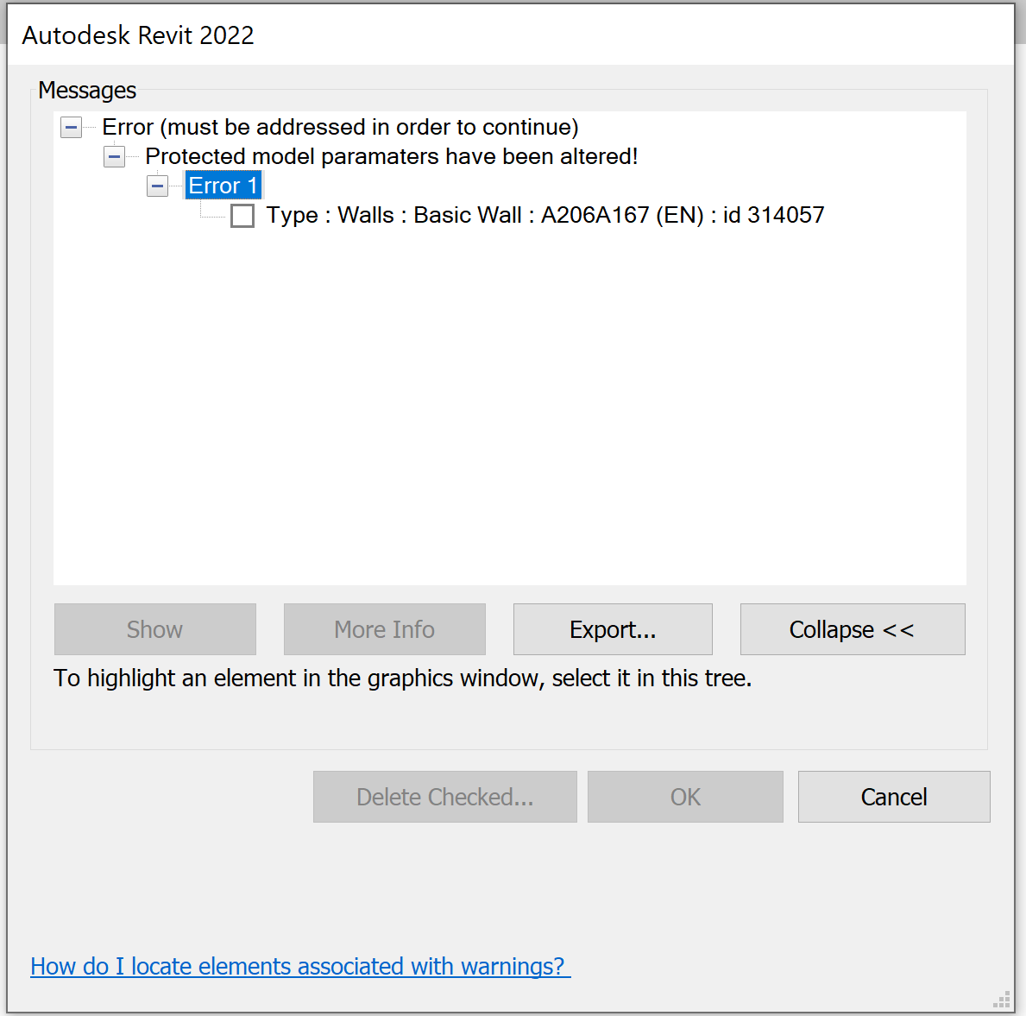

Consumer

Receives the BIM with the embedded ground truth data in the extensible storage from the vendor.

Allowed to interact the model but prohibited to modify certain properties.

Basically, the consumers are left with the power to interact with model however they wish. The interaction is based on trust that they will not interfere with prohibited properties.

Incase the consumer opens a modified model from whichever source; an informational dialog box is provided to inform the user that the model is not original version. He / she may choose to proceed with the tampered model or contact the vendor for the original model.

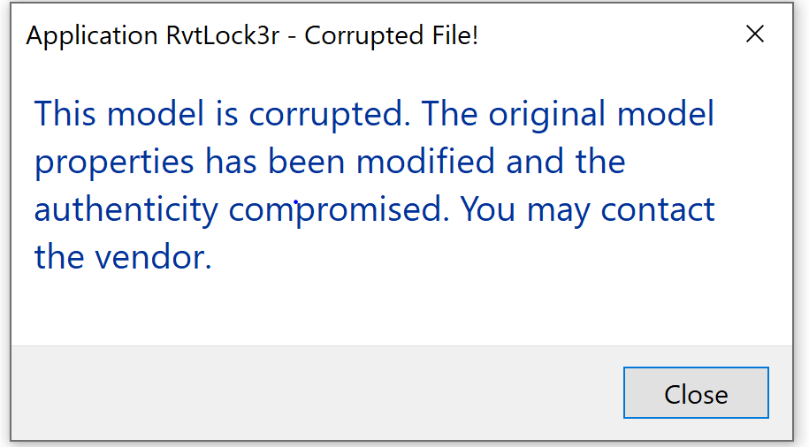

During interaction with model, consumer may intentionally or unintentionally modify a prohibited property. When he / she tries to save, informational dialog box is provided informing the user that the property is prohibited, and he /she is not allowed to modify it.

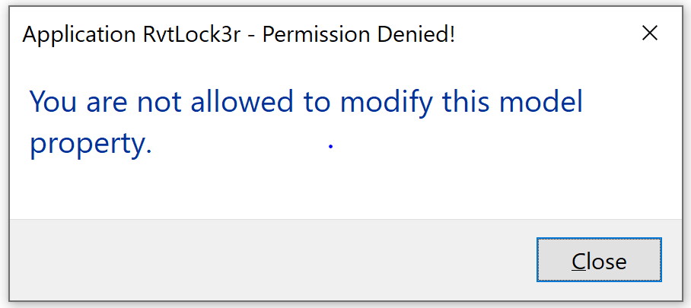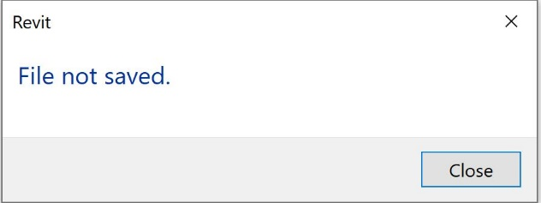

Incase the consumer decides to close Revit amidst modification, an optional dialog box is provided for the consumer’s decision to save or not save the model.

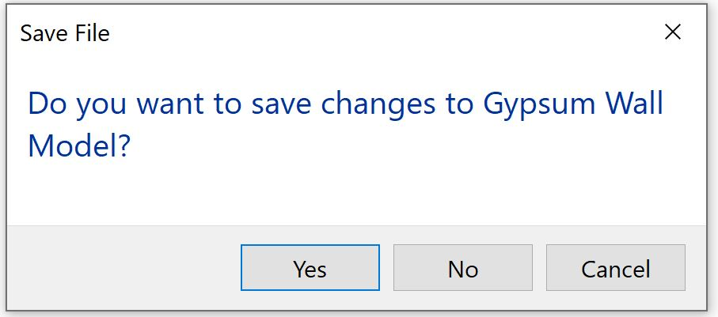

If the consumer chooses `**Yes`**, the model is saved and if `**No`** the model remains unchanged.